**Data Analyst in Power BI Data-Camp 2025**

**Section 4: Case Study: Analyzing Customer Churn in Power BI**

1. **Exploratory Analysis**

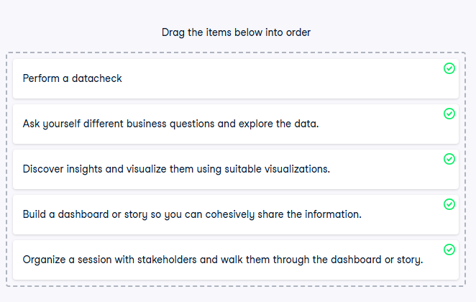

**Exercise 1.1** 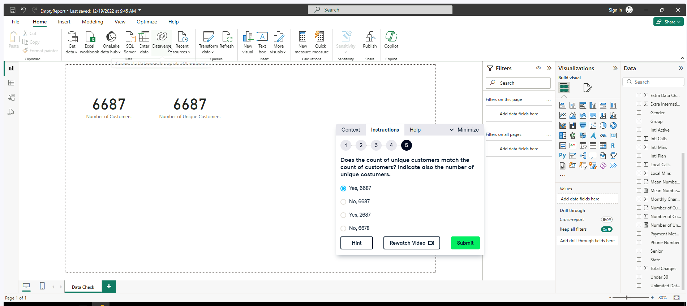

[**DISTINCTCOUNT function (DAX) - DAX | Microsoft Learn**](https://learn.microsoft.com/en-us/dax/distinctcount-function-dax)

**Exercise 1.2**

[IF function (DAX) - DAX |**

**Exercise 1.3**

**Exercise 1.5**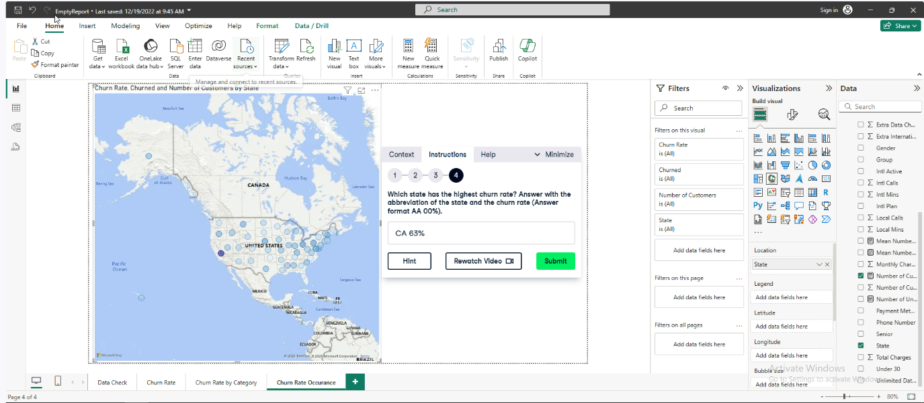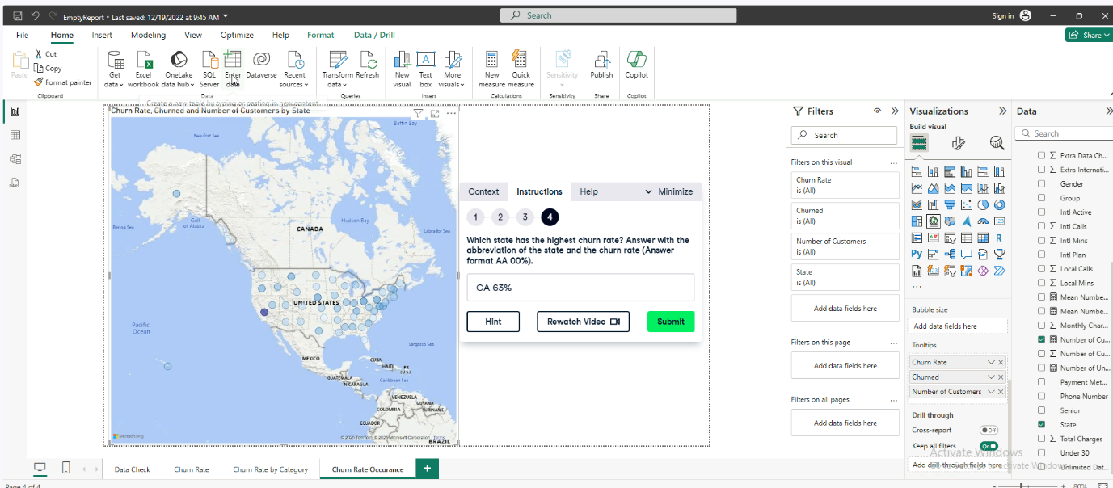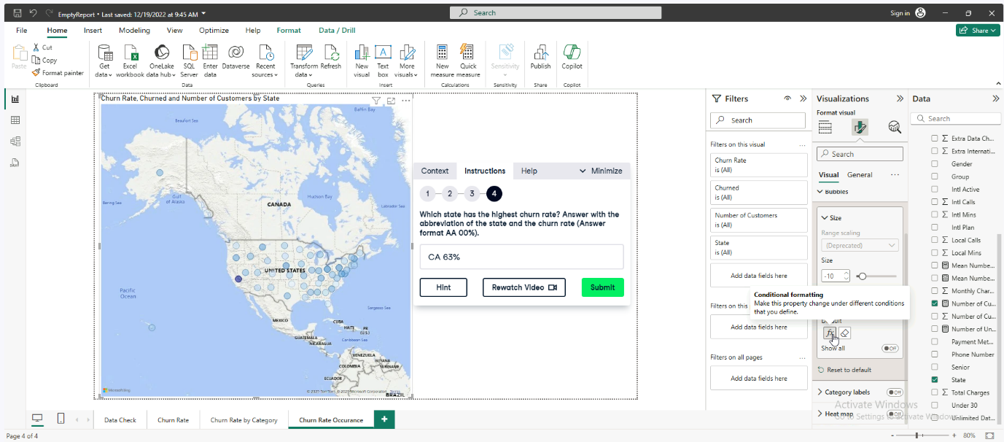

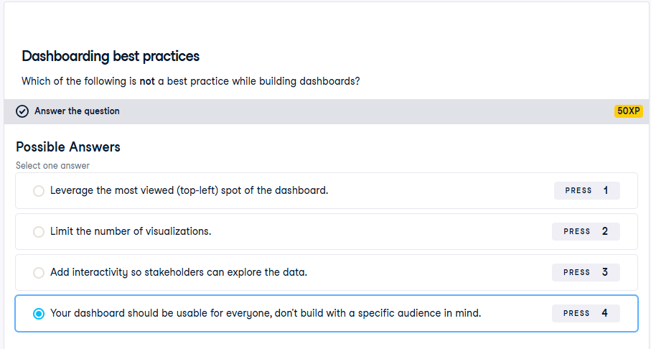

1. **Investigating Churn Patterns**

**Exercise 2.1**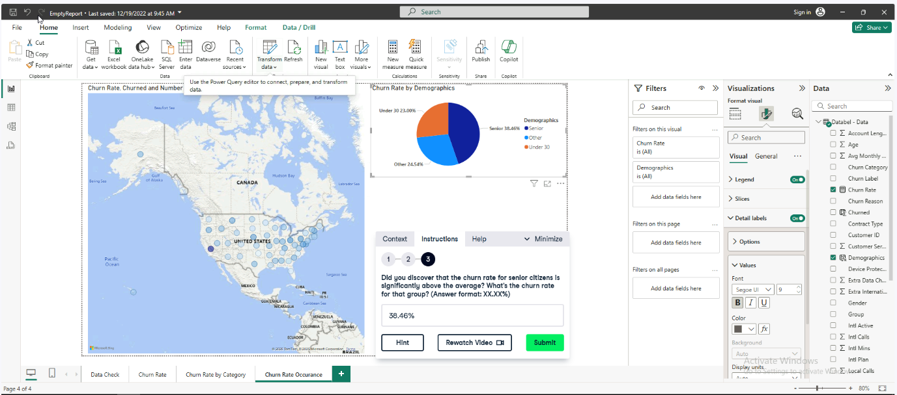

**Exercise 2.2**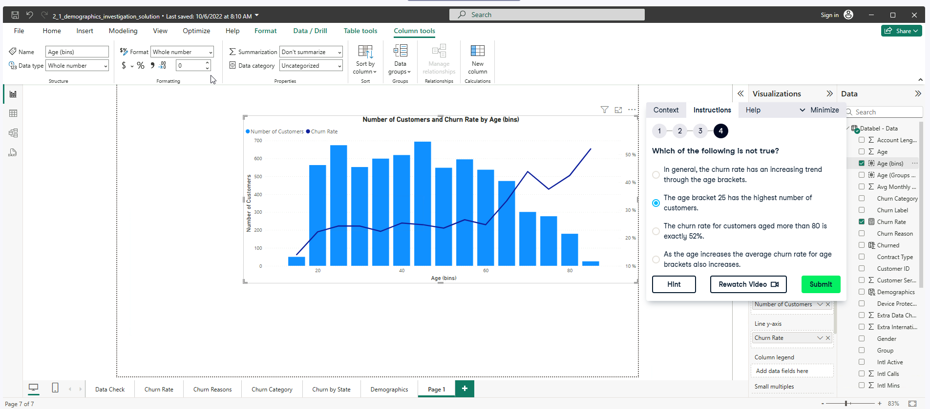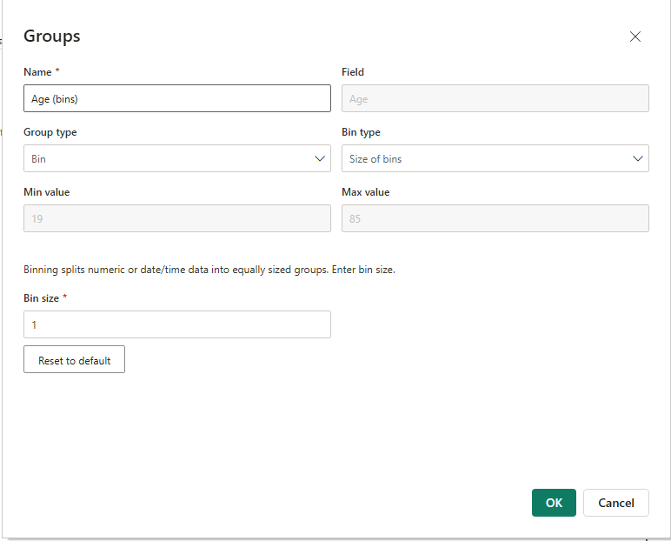

**Exercise 2.3**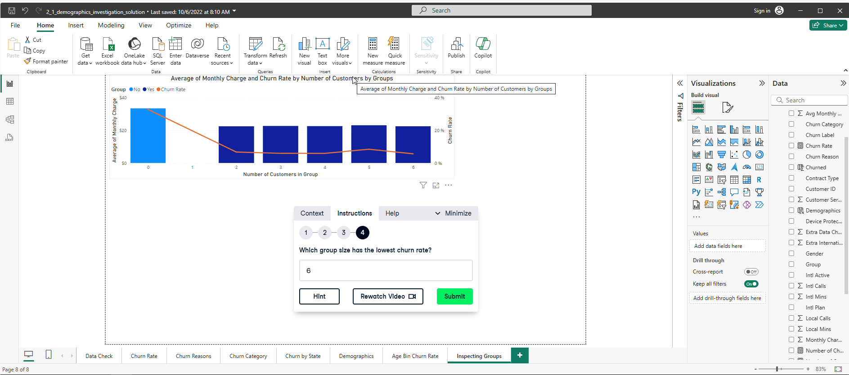

**Exercise 2.4**

[SWITCH function (DAX) - DAX | Microsoft Learn](https://learn.microsoft.com/en-us/dax/switch-function-dax)

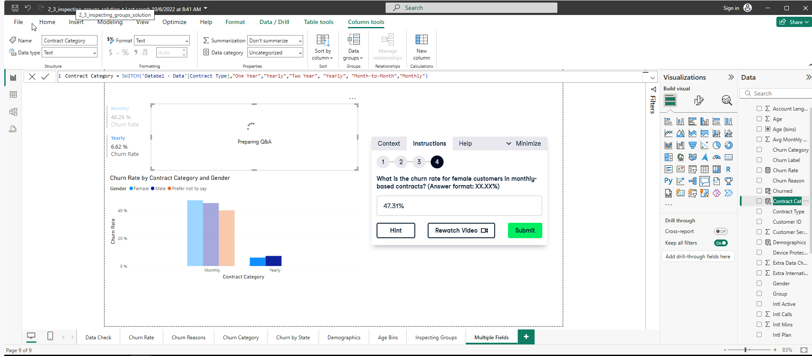

**Exercise 2.5**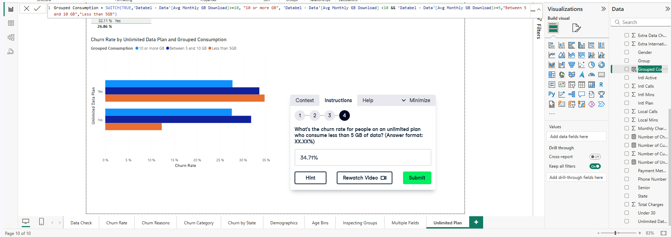

**Exercise 2.6**

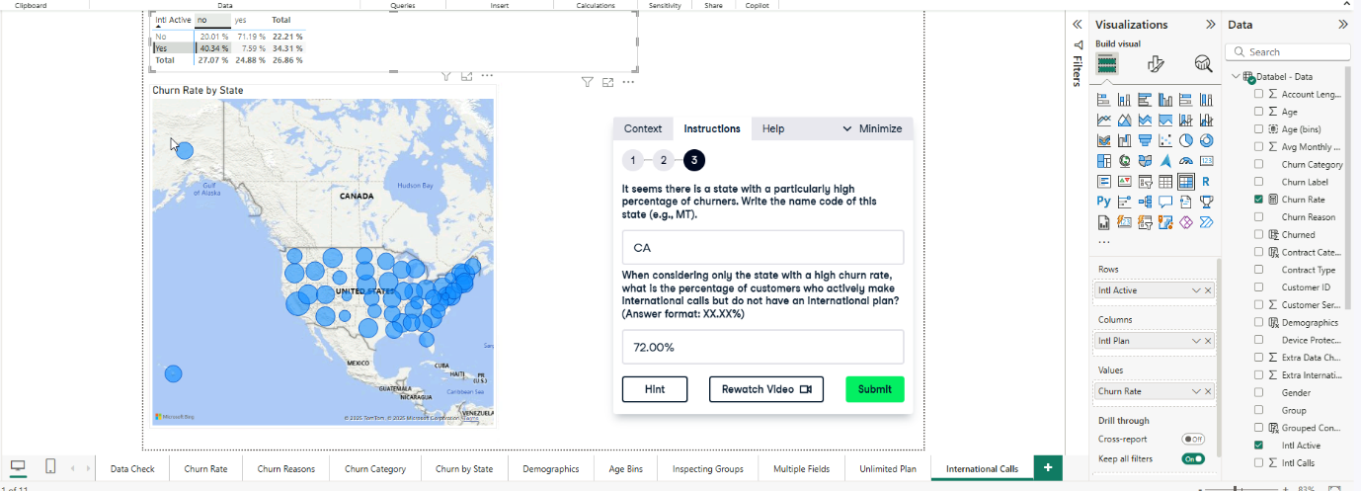

**NOTE: columns are Init Plan and rows are Intl Active**

**Exercise 2.7**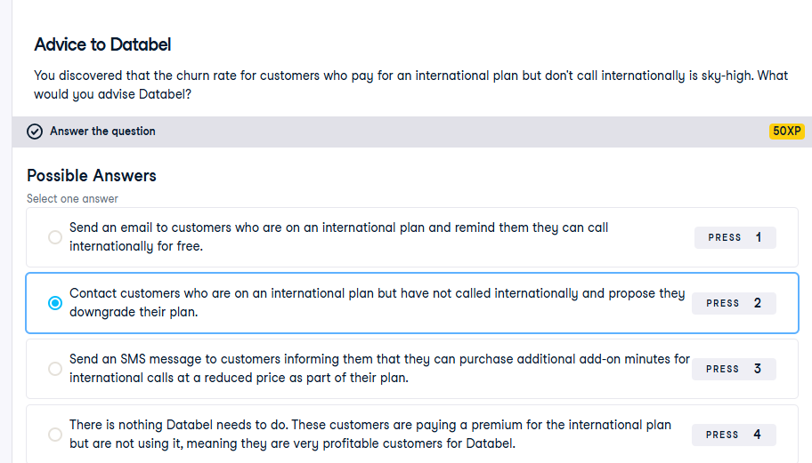

**Reason:** That's a great idea! Proposing a cheaper plan and explaining the rationale will increase customer satisfaction and stop customers from churning.

**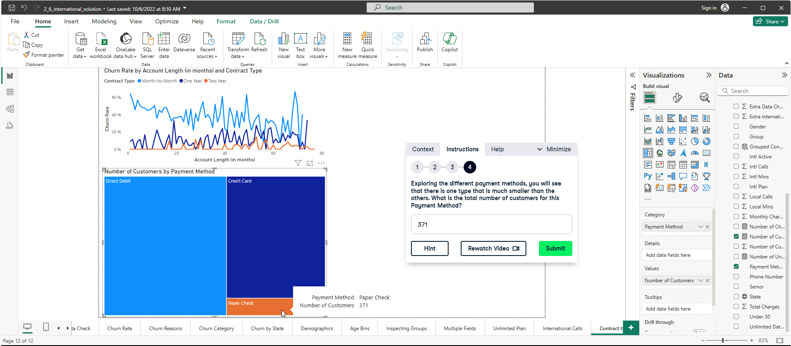

1. **Visualizing your Analysis**

**Exercise 3.1**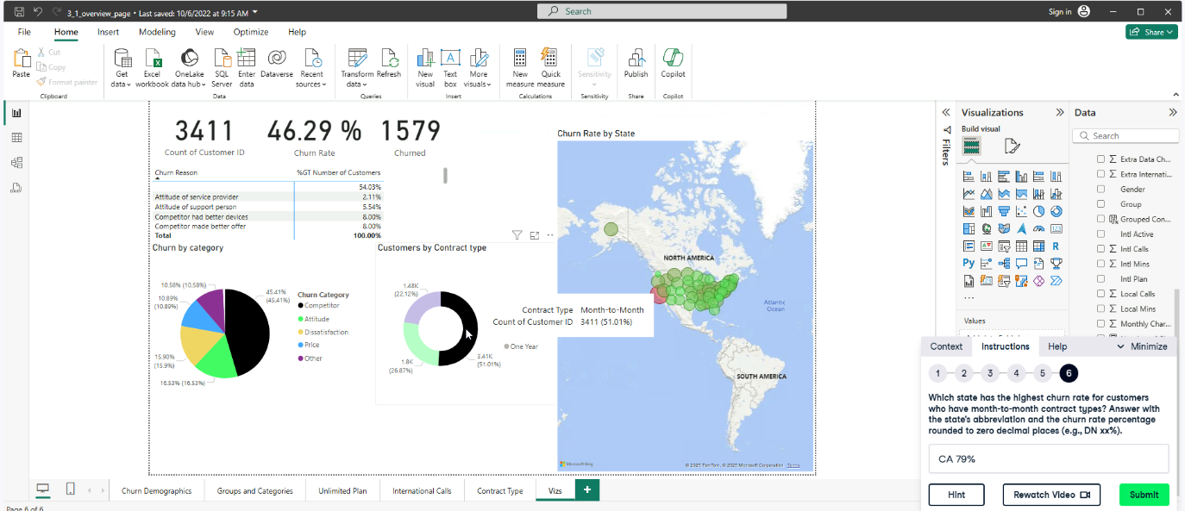

**Exercise 3.2**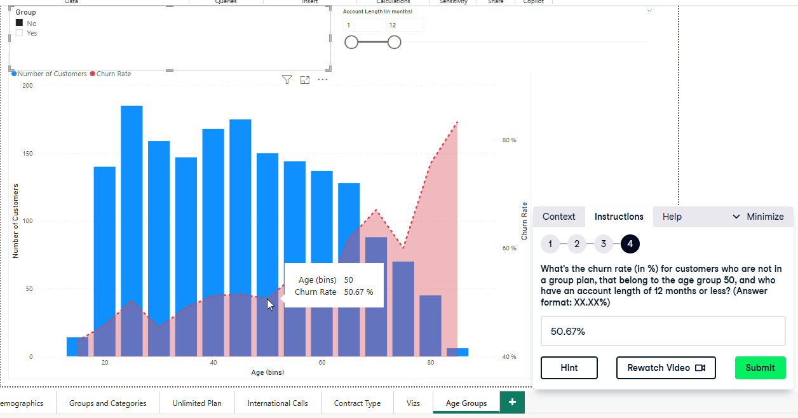

**Exercise 3.3**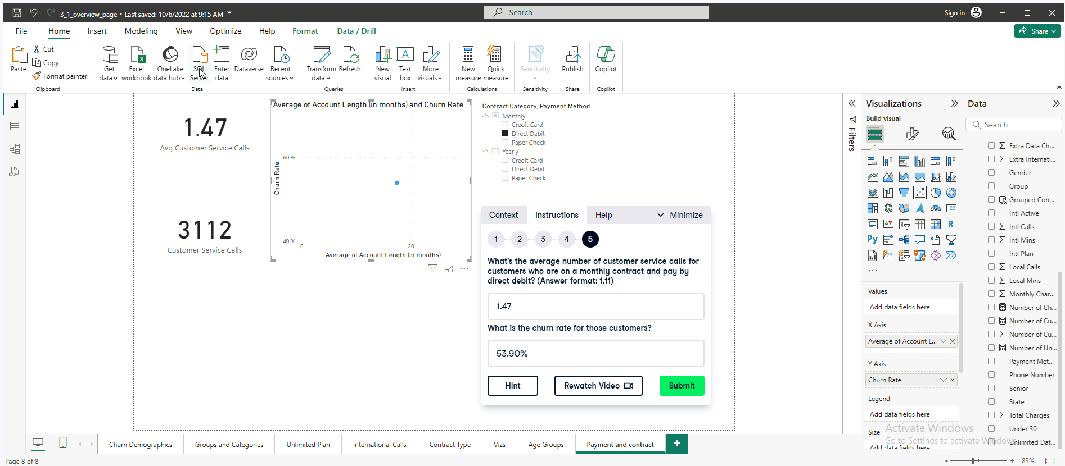

**Exercise 3.4**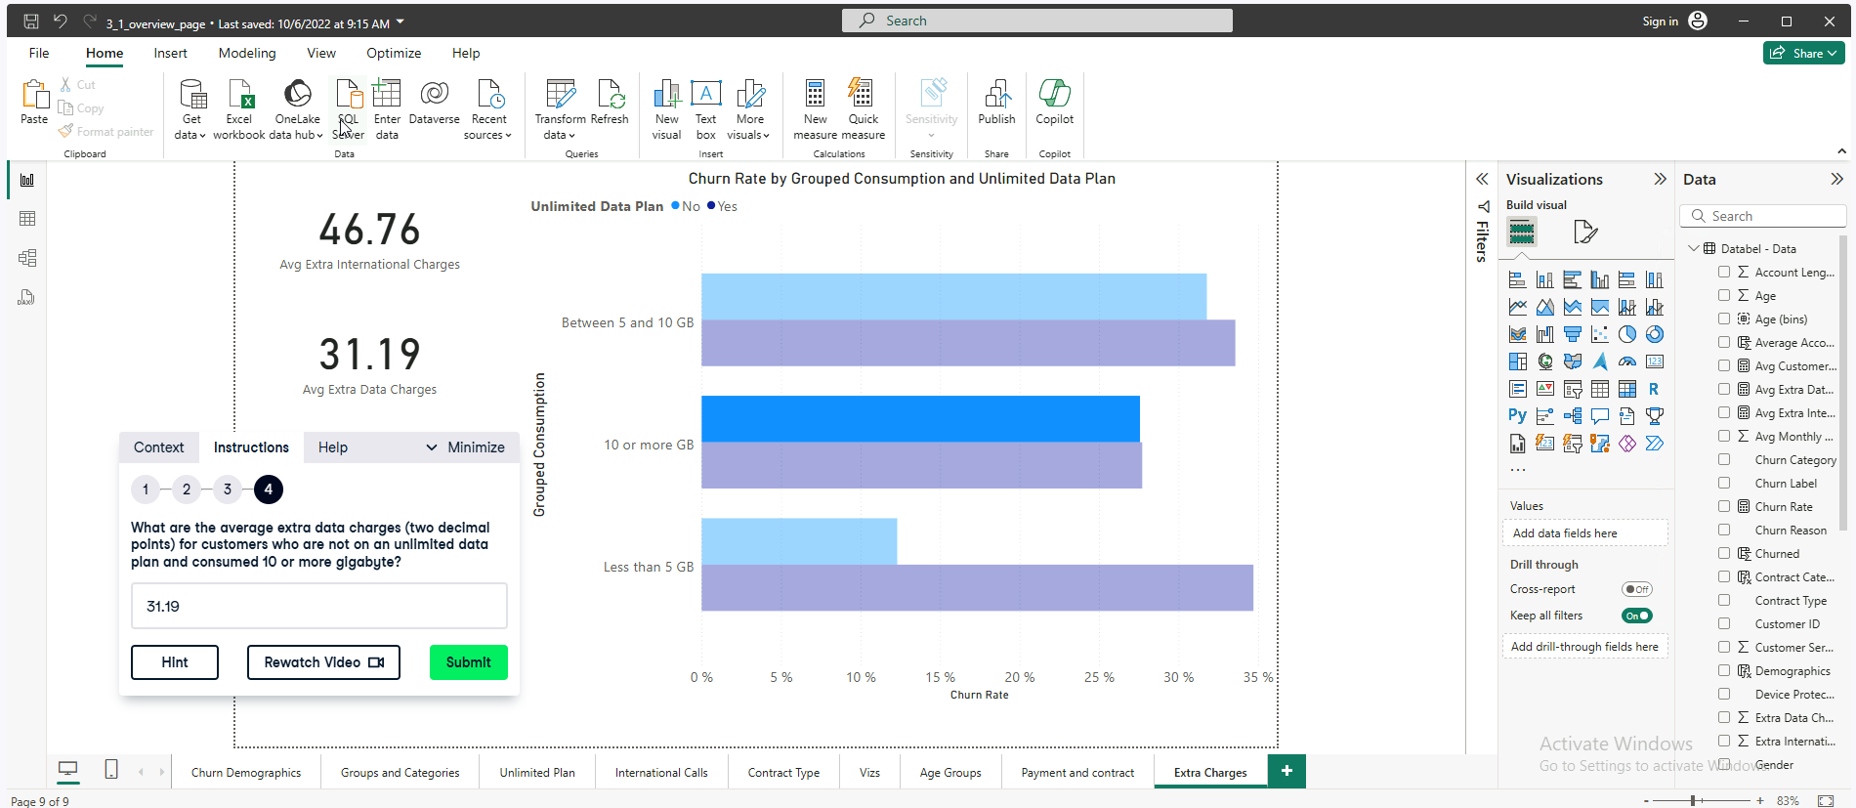

**Exercise 3.5**